DNS

1. Create s3 bucket with static site, block all public access (<https://www.free-css.com/free-css-templates>)  
   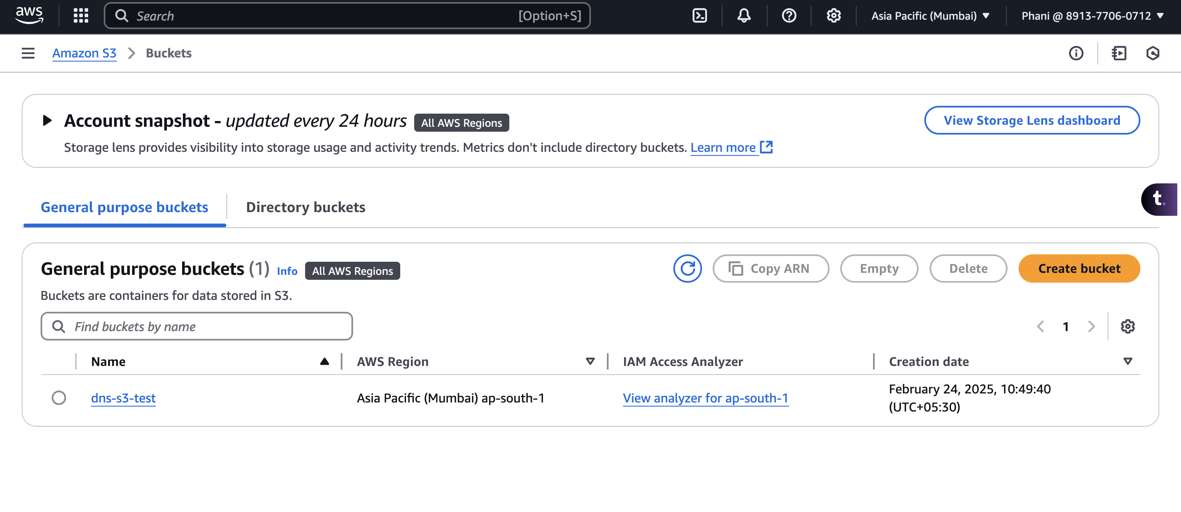
2. Enable static website hosting  
   A screenshot of a computer

   AI-generated content may be incorrect.
3. Create cloud front – provide the cname as domain name and create SSL certificate  
    copy paste the policy to the s3 bucket  
   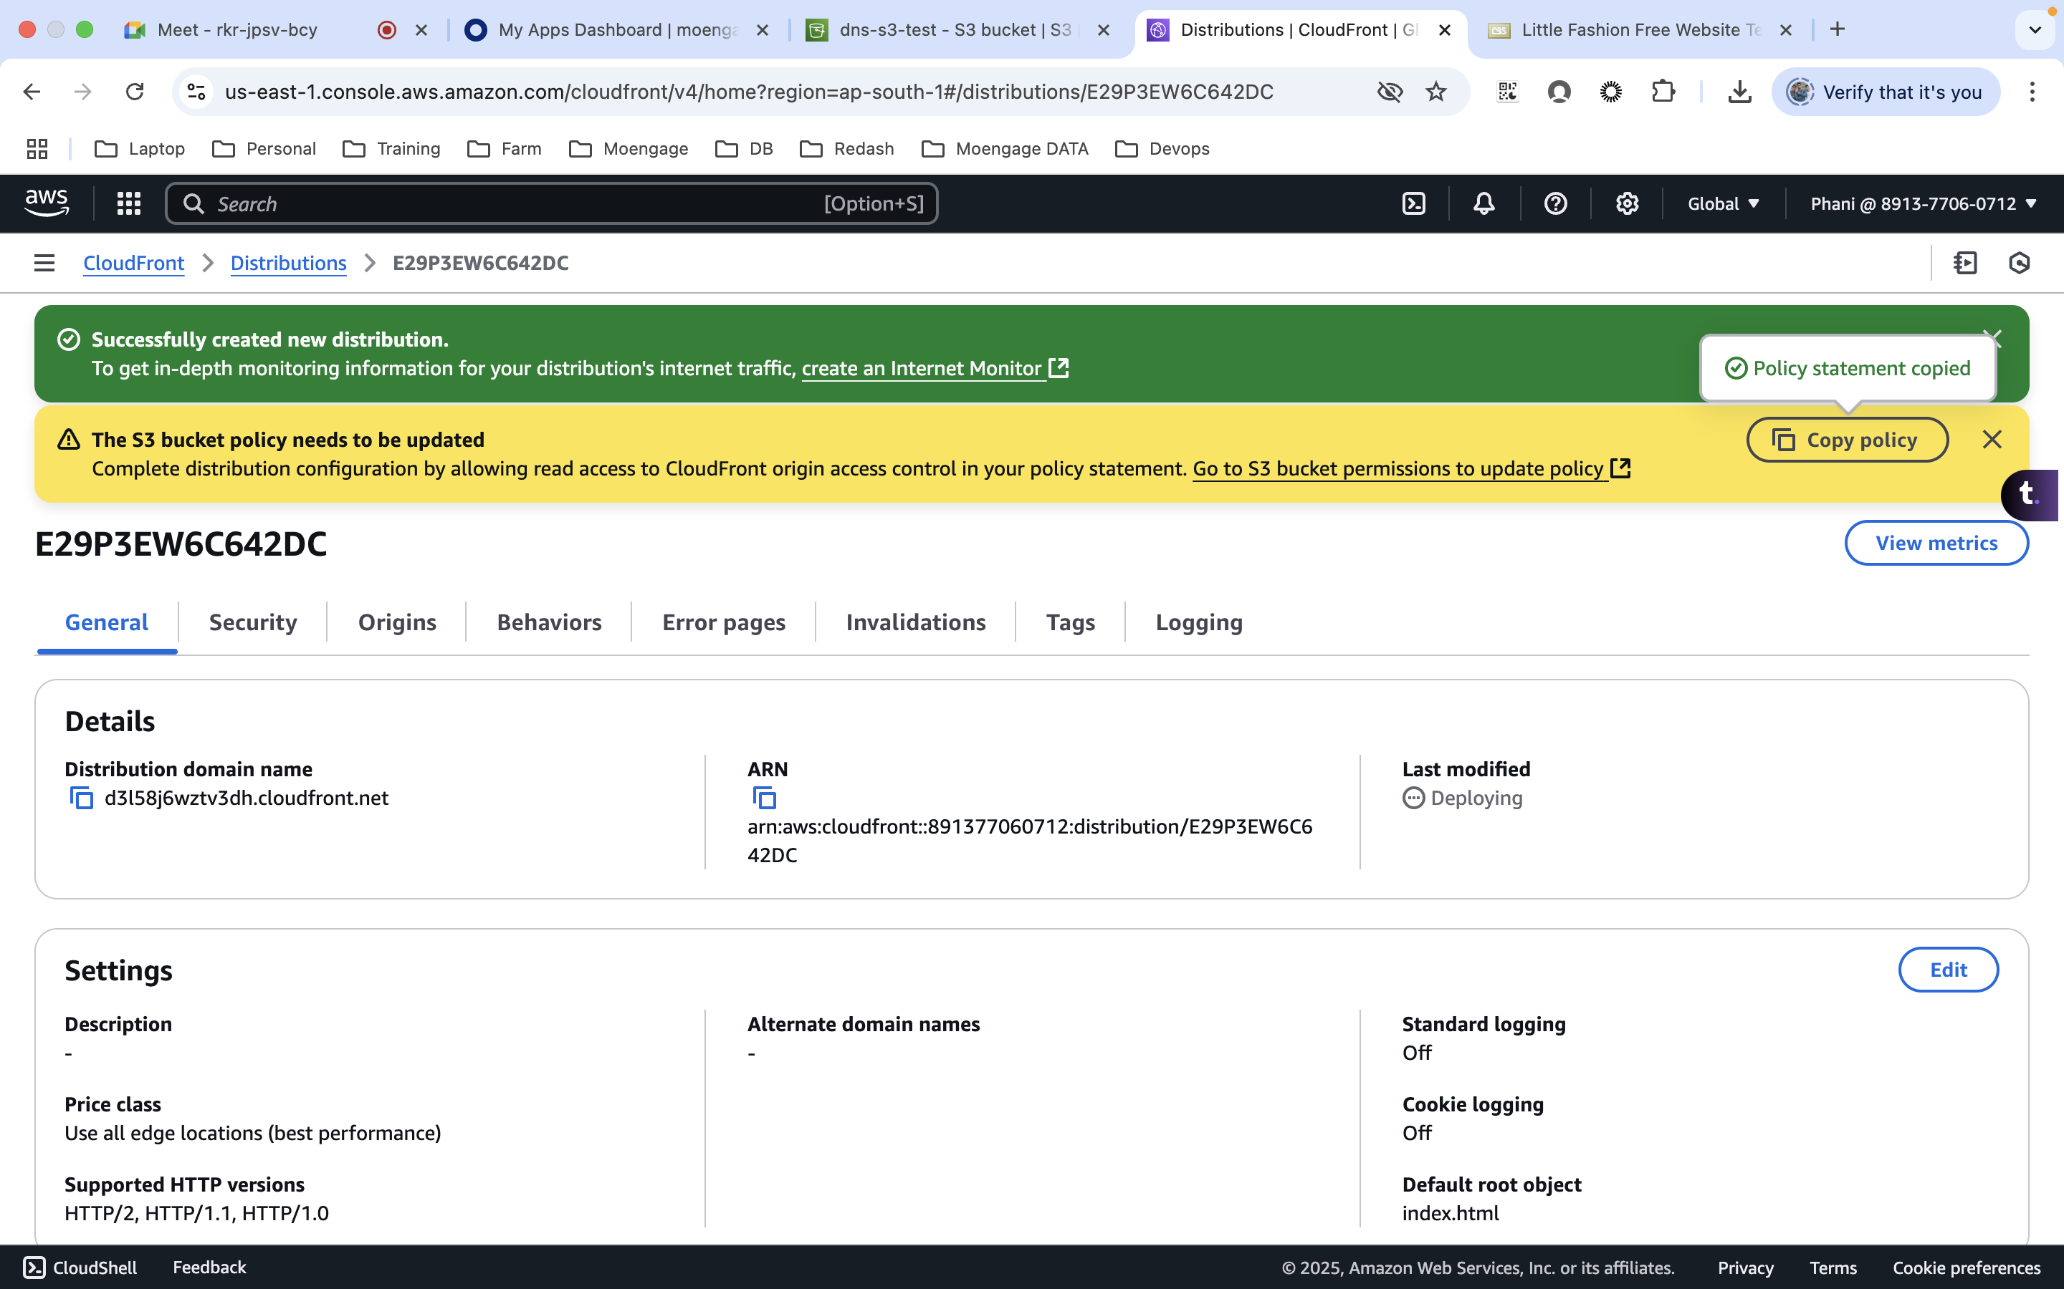
4. Now the clodfront will have access to the s3 bucket using **Distribution domain name**A screenshot of a computer

   AI-generated content may be incorrect.
5. Create Route53  
   Get the domain name from the godaddy   
   Once the route 53 created, update the nameservers in the platform where we bough the domain name (Godaddy)  
   